**Assignment (Boto3)**

1. Write a script that builds three EC2 Instances and returns the Public IP of each instance. Use ubuntu AMI.(use t2.micro)

1. Write a script that snapshots a volume in us-west2.

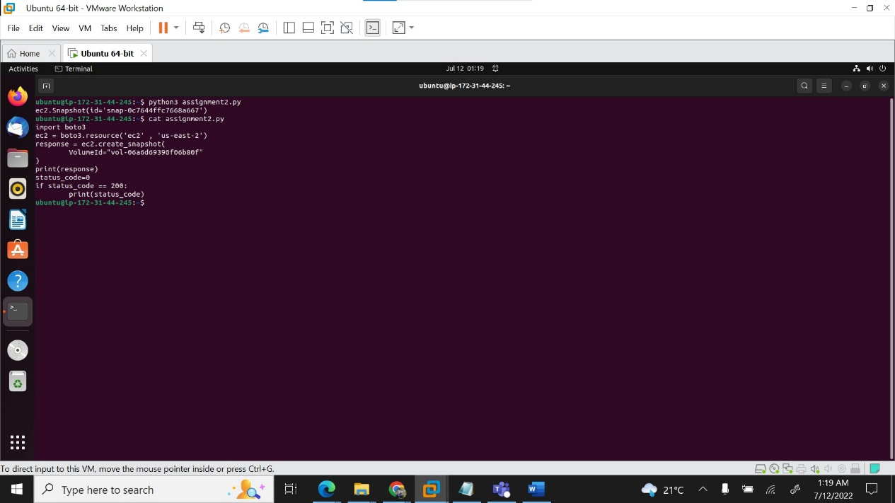

1. Write a script that will create 2 EC2 instances and add them to the new Elastic Load Balancer.

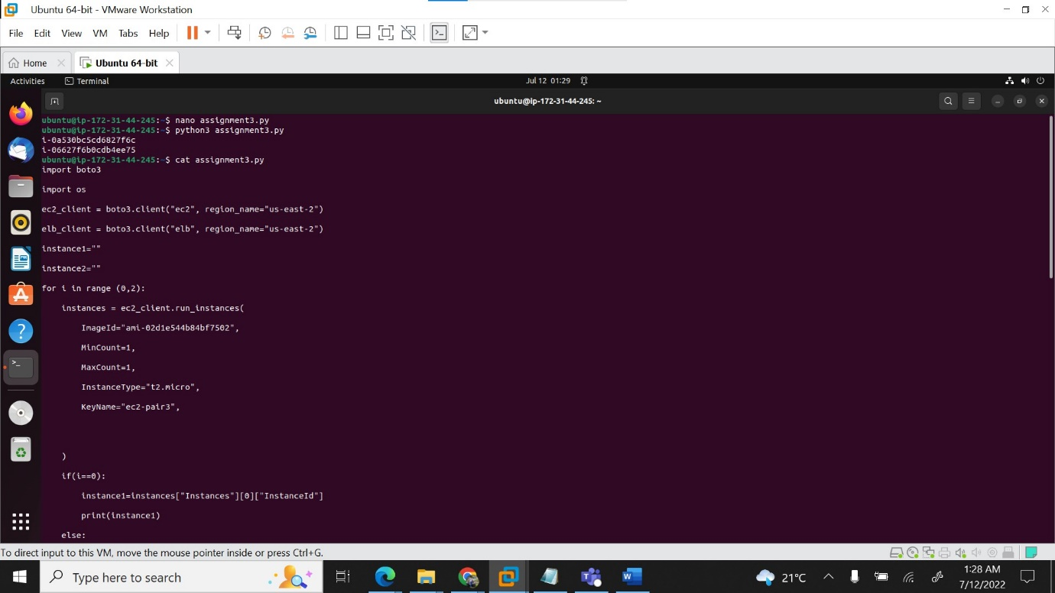

1. Write a script to create S3 bucket and upload a bunch of files to it.

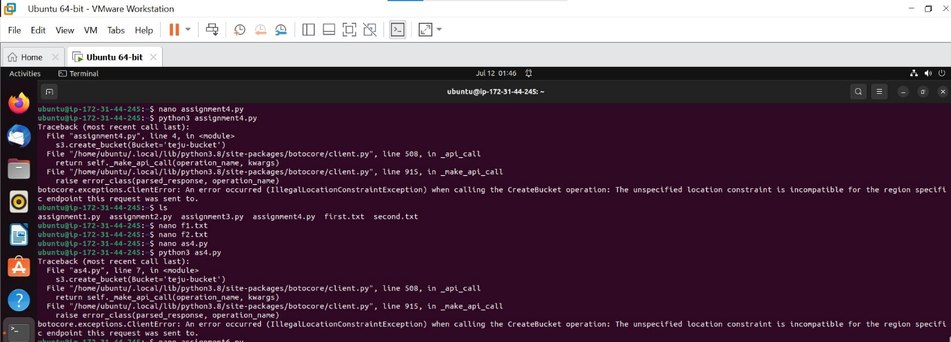

1. Implement a CRON job using AWS Lambda to stop EC2 instance and start. (Once EC2 is stopped. After 5mins EC2 should Start).
2. Write code that deletes everything you have created from these exercises. It should:

Stop and Delete all EC2 instances

Delete all Volumes.

